Workplace Theft Prevention
Things you can do
- Lock your purse, wallet, or other personal belongings in the desk when not in use, and take the key with you.
- Take your purse, wallet, keys, or any medications you might need with you during a non-emergency building evacuation.
- Lock up valuables when leaving for the day, both personal property and state property.
- If a crime occurs in your work area, leave the area alone in case evidence can be obtained.
- Keep nonpublic office doors to common areas, such as hallways, locked to prevent unauthorized access to work areas.
- In reception areas, use psychological barriers to discourage unauthorized personnel from accessing work areas. Example, stanchions, signage, etc.
- Monitor and control who is entering your workplace, current employees, former employees, and commercial delivery and service personnel.
- Report broken doors, windows and locks to your organization’s or building’s security personnel as soon as possible.
- Monitor and report suspicious activity in or near your facilities entry/exit points, loading docks, parking areas, garages, and immediate vicinity.
Call Capitol Police IMMEDIATELY to report larcenies that occur in your workplace.
Things you shouldn’t do
- Don’t leave valuables in plain sight.
- Don’t make it known that you leave cash in your desk or office.
- Don’t leave cash in your desk or office if you don’t have to.
The majority of larcenies from state office buildings are preventable.
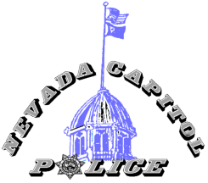
101 North Carson Street, Carson City, NV 89701
775-684-5700 http://capitolpolice.nv.gov/

